Determination of triglyceride levels in Nucella ostrina using quantitative NMR spectroscopy

DEPARTMENTS OF BIOLOGICAL SCIENCES AND OF PHYSICAL SCIENCES - HONOURS THESIS

Investigator: Tallis Dixon
Supervisors: Dr. Louis Gosselin and Dr. Bruno Cinel


INTRODUCTION
The intertidal zone along the west coast of British Columbia is a biologically rich and ecologically complex environment. Home to a wide range of marine invertebrates, including molluscs, crustaceans, echinoderms, poriferans, and cnidarians — this zone is defined by its twice-daily exposure to air and submersion by the tides. These fluctuations subject organisms to rapidly changing and often extreme conditions, including desiccation, variable air temperatures, wave action, and ultraviolet (UV) radiation (Cubillos et al. 2018; Mendt and Gosselin 2022). Despite these stressors, the intertidal region supports a large biodiversity of organisms that have evolved to thrive under these conditions.
Survival often depends on the energy reserves the organism possesses; among the most important components of these energy reserves are lipids. Lipids are small, hydrophobic molecules that are both structurally diverse and functionally critical to biological systems (Imbs et al. 2021). In marine invertebrates, they serve as integral components of cell membranes, long-term energy stores, and metabolic indicators. The field of lipidomics continues to grow, supported by advances in analytical tools such as mass spectrometry and chromatography, and has revealed considerable variation in lipid composition across marine taxa. These advancements have highlighted the important role lipids play in supporting development, stress tolerance, and survival (Imbs et al. 2021).
A key lipid class involved in energy storage is triglyceride (TG), a molecule composed of a glycerol backbone bonded to three various fatty acid chains via ester linkages (Rayssac et al. 2010). TG function as energy reservoirs, mobilized during times of high energetic demand—such as starvation, metamorphosis, reproduction, or stress—and replenished under conditions of food abundance. The ability of an organism to store and access TG is closely tied to its physiological resilience, especially during early life stages when external feeding is limited or non-existent (Rayssac et al. 2010).
Figure 1. General Triglyceride structure possessing three different fatty acid side chains.
Numerous studies have demonstrated the importance of lipid reserves in supporting early development. For instance, Holland and Spencer (1973) observed that oyster larvae subjected to just two days of starvation had a 65.7–86.4% decrease in their total lipids and proteins, but only 2.3–13.3% of their carbohydrates. This suggests that lipids and proteins serve as the primary fuels for development and maintenance, while carbohydrates are conserved. These losses were most pronounced during metamorphosis, a period of intense morphological change when larvae are unable to feed. Similar results were reported by Whyte et al. (1992), who documented that in scallop (Crassadoma gigantea) larvae, lipid accounted for nearly 60% of total energy loss between the larval and early juvenile stages. Together, these findings highlight the central role of lipids, and TG in particular, in fuelling both development and survival in early life.
Developmental strategy influences not only how energy is used but also how much is initially required. Holland et al. (1975) compared energy reserves in four species of Littorina, two of which develop via an indirect planktonic development and two of which undergo direct development. The indirect planktonic species were found to have nearly three times the lipid content of their direct-developing counterparts. This difference reflects the greater energy demand associated with swimming and dispersal in the absence of feeding.
Nucella ostrina, a predatory gastropod common to the rocky shores of the northeastern Pacific, is a direct-developing species. Fertilization is internal, and larvae develop over a few months within egg capsules laid on the substrate. Upon hatching, juveniles crawl away from the capsule as miniature versions of the adult, Gosselin and Chia (1995). Because these juveniles do not feed until they are fully mobile and established in the intertidal zone, their development and early survival are entirely dependent on the energy reserves provided by the parent. These energy stores must sustain the full course of embryogenesis and carry juveniles through the period immediately following hatching, when desiccation, predation, and limited food access are all high-risk factors. Thus, maternal investment is crucial in determining early-life success.
Egg size is often used as a proxy for maternal investment, yet it does not always accurately predict energy content. McEdward and Morgan (2001), investigated several asteroid species and found that one species produced eggs three times larger than another but with no corresponding increase in energy content. This suggests that composition—not just size—determines the effectiveness of maternal provisioning. For N. ostrina, in which the development of the juvenile is fueled by energy deposited in the egg by the maternal parent, identifying the actual energy levels, especially TG levels, is more informative than the size of the egg capsule alone.
As global climate conditions shift, the importance of understanding how energy is stored and used becomes even more critical. Sea surface temperatures are projected to increase by 2–4°C by the end of the 21st century (Valles-Regino et al. 2015), introducing new metabolic challenges for intertidal invertebrates. Molluscs are vulnerable due to their slow movement, soft bodies, and lack of physiological capacity for thermoregulation. Increased temperature accelerates biochemical reactions and causes a higher metabolic rate, therefore increasing energy demands and depleting energy reserves.
Lipids are replenished through feeding, with marine invertebrates acquiring essential lipid building blocks from their food. In the predatory N. ostrina, this diet primarily consists of other intertidal invertebrates such as barnacles and mussels (Mendt and Gosselin 2022). In contrast, some herbivorous marine snails primarily rely on algae and biofilms as their predominant energy source. Although lipid structure and composition are known to vary across species (Holland et al. 1975; Farías 2003), few studies have investigated whether trophic strategy — specifically herbivory versus predation — leads to distinct patterns in lipid profiles across taxa. Examining whether predators and herbivores share similarities in the types or quantities of stored lipids could clarify the extent to which diet influences lipid composition and provide insight into how energy is allocated and optimized. This comparison may also help predict which trophic groups are better equipped to cope with rising energetic demands under climate change. In addition to consuming different food sources, predators and herbivores also differ in feeding frequency and mode—predators tend to feed intermittently on large, energy-rich prey, while herbivores graze continuously on lower-energy resources such as algae and biofilms. These contrasting strategies may shape not only how much energy is stored but also the form in which it is stored, reflecting adaptations to distinct ecological pressures. Therefore, understanding how diet influences internal energy reserves is critical, as these reserves support not only the adult’s survival under environmental stress but also the provisioning of energy to offspring during early development. By examining how TG levels vary with life stage, diet, temperature exposure, and food availability, we can begin to understand the adaptive strategies that support these organisms in fluctuating and stressful environments.
This study aims to (1) determine how lipid composition varies across molluscan predators and herbivores; (2) determine how lipid levels decrease in adult N. ostrina when exposed to varying temperatures, with and without access to food to replenish lipids lost; (3) assess if lipid profiles vary across life stages; (4) to compare the lipid profile of juvenile and adult N. ostrina collected from two field sites that differ in environmental conditions and body size trends; and (5) assess whether the lipid profile of N. ostrina reflects that of its main prey, the barnacle Balanus glandula.
METHODS
Animal Collection
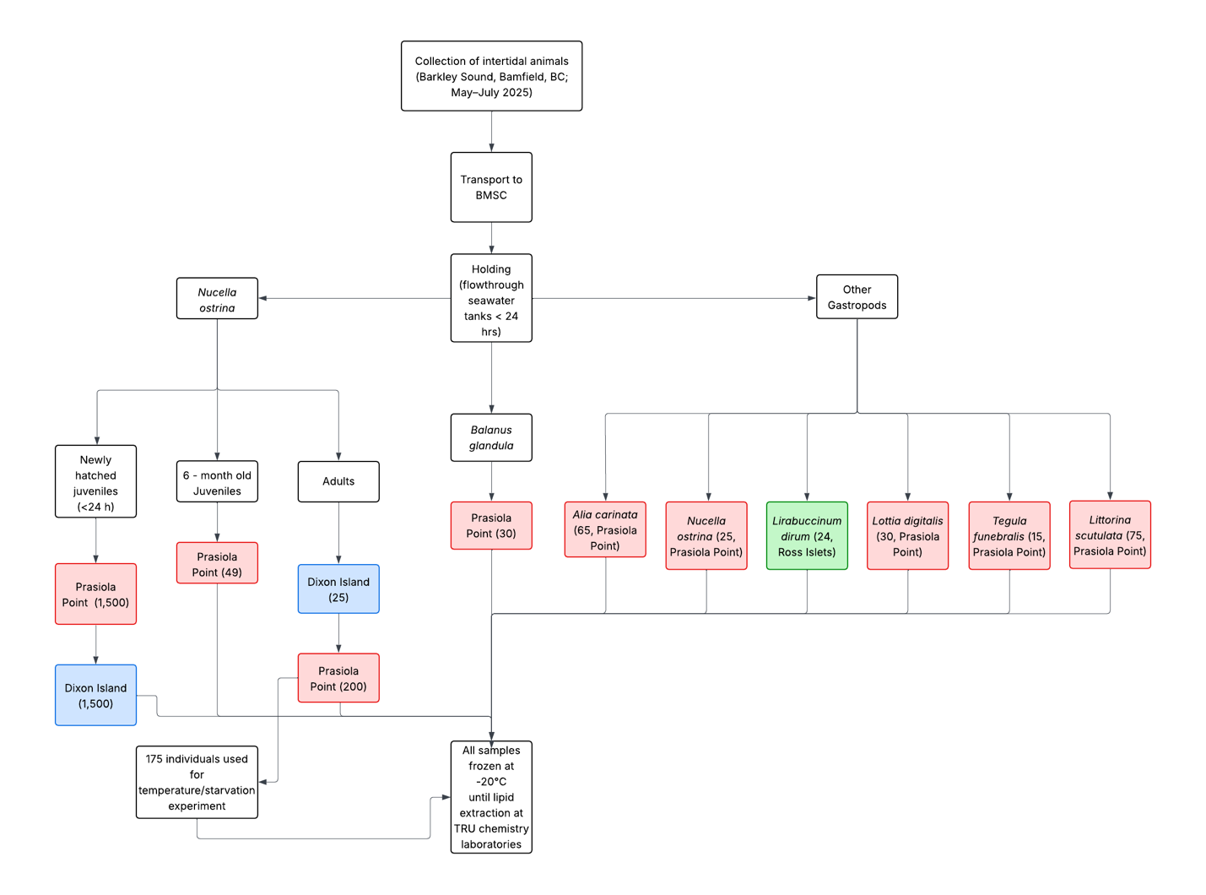
All animals were collected by hand from intertidal habitats in Barkley Sound, Bamfield, BC, between May and July 2025. Specimens were transported to the Bamfield Marine Sciences Centre (BMSC) and maintained in flow-through seawater tanks for no longer than 24 hours prior to processing. A total of 250 adult Nucella ostrina were collected, including 25 individuals from Wizard Island, 25 from Dixon Island, and 200 from Prasiola Point. From the same location, 49 older juveniles (~6 months old) were obtained, along with ripe egg capsules that yielded approximately 1,500 newly hatched juveniles (<24 hours old). Comparable numbers of newly hatched juveniles (~1,500 each) were also collected directly from Wizard Island and Dixon Island. Additional intertidal gastropods were collected, including Alia carinata (65 individuals), Littorina scutulata (75 individuals), Tegula funebralis (15 individuals), and Lottia digitalis (30 inndividuals) from Prasiola Point, as well as Liabucinum dirum (24 individuals) from Ross Islets. Adult barnacles, Balanus glandula (30 individuals), were also collected from Prasiola Point.
Figure 2. Workflow of animal collection from Barkley Sound, BC.
Animal Experiments
Starvation and temperature experiments were conducted on adult N. ostrina at the BMSC. A total of 175 adults were used; 25 were frozen at the start of the experiment to serve as a baseline, and the remaining 150 were assigned to three 40-L tanks equipped with thermometers, water pumps, and filters. Two tanks were fitted with heaters to maintain elevated seawater temperatures of 19 °C and 21 °C, while the third tank remained at ambient temperature (~15 °C). Within each tank, three mesh-sided plastic containers (20 × 20 × 10 cm) were used to establish feeding treatments. Two containers held fed groups of 10 and 15 snails provided with barnacle-covered rocks, while the third container held a starved group of 25 snails maintained without food. Thus, each temperature treatment included both fed and starved groups. The experiment lasted 19 days, during which barnacle rocks were replaced every 2–3 days and tanks were cleaned every 5–6 days. At termination, all snails were blot-dried and frozen at –20 °C in replicates of five for lipid analysis.
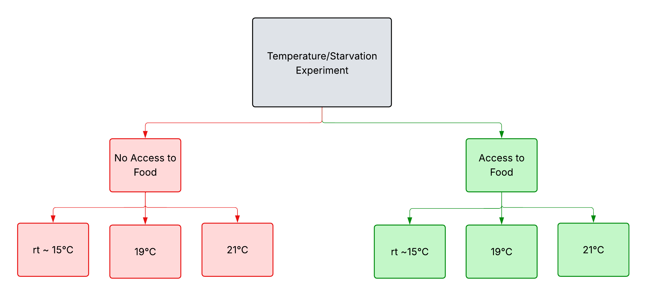
Figure 3. Organizational flowchart of laboratory temperature/starvation experiments.
Animal Preservation
Following collection and experimentation, all animals were blot-dried and divided into replicates prior to freezing. Adult gastropods and barnacles were assigned to five replicates, with 5–25 individuals per replicate depending on species and size, while newly hatched juveniles were divided into three replicates of 500 individuals each. All replicates were placed into appropriately sized centrifuge tubes (50 mL, 25 mL, or 1 mL) and stored at –20 °C for subsequent lipid analysis.
All samples were frozen at 20°C and transported from BMSC to Thompson Rivers University (TRU) Chemistry laboratories for chemical analysis.
Lipid Extraction
Lipid extraction steps follow the method of Bligh and Dyer (1959) with minor modifications. For adult molluscs, each sample was measured and weighed. Frozen replicates were thawed for approximately 20 minutes, shells were cracked with a mallet and tweezers, the body of the snail was removed, and then the shell and body were separately weighed. The bodies of each replicate were ground with a mortar and pestle. During grinding, 2 mL of methanol and 1 mL of chloroform were added, and grinding continued for ~5 minutes until a homogeneous snail paste was obtained. The homogenate was transferred to a glass centrifuge tube, after which 1 mL of chloroform and 1 mL of deionized water were added. Samples were then placed in an ultrasonicate ice bath for ~1 minute to further disrupt cells, vortexed for 30 seconds, and poured onto a Büchner funnel under light water suction for 2–3 minutes through a 1.5 cm filter paper with 5 µm of retention. The resulting filtrate was collected in a clean glass centrifuge tube and left to stand for 5 minutes to allow phase separation. The lower chloroform layer was carefully pipetted into a pre-weighed glass vial, dried under nitrogen gas for ~15 minutes, and further dried under vacuum before reweighing to determine the lipid yield. Samples were sealed with Parafilm and stored at –20 °C until NMR analysis.
NMR
All the ¹H NMR spectra were recorded with a Bruker 500-MHz NMR spectrometer (AVANCE III) equipped with broadband (BBO) probe. “The solutions were prepared by dissolving approximately 5-10 mg of algal extracts, FAMEs, vegetable oils, and biodiesels in 0.7–0.8 mL of CDCl3 containing the internal reference tetramethylsilane” (Sarpal et al. 2015). The following parameters were used for each recording: relaxation delay 0; acquistition time 3.17; pulse width 7.740; number of scans 1600, chemical shift range 0 – 20.67 ppm.
The ¹³C NMR spectra was recorded with Bruker 500-MHz NMR spectrometer (AVANCE III) equipped with broadband (BBO) probe. The overnight recordings (260000 scans) were preformed with a relaxation delay of 0 in composite pulse decoupling mode, a pulse width of 10 and a sweep width of 0 – 236.6ppm.
Statistical analysis
Lipid species across different life stages and treatments will be compared by
calculating the mean values across the samples and a one-way analysis of variance (ANOVA) to
identify specific group differences. All statistical analyses will be conducted using RStudio.

REFERENCES
Bligh EG, Dyer WJ. 1959. A RAPID METHOD OF TOTAL LIPID EXTRACTION AND PURIFICATION. Can J Biochem Physiol. 37(8):911–917. doi: https://doi.org/10.1139/o59-099
Cubillos VM, Ramírez EF, Cruces E, Montory JA, Segura CJ, Mardones DA. 2018. Temporal changes in environmental conditions of a mid-latitude estuary (southern Chile) and its influences in the cellular response of the euryhaline anemone Anthopleura hermaphroditica. Ecol Indic. 88:169–180. doi: https://doi.org/10.1016/j.ecolind.2018.01.015
Farías A. 2003. Polyunsaturated fatty acids in total lipid and phospholipids of chilean scallop Argopecten purpuratus (L.) larvae: effects of diet and temperature. Aquaculture. 228(1–4):289–305. doi: https://doi.org/10.1016/S0044-8486(03)00272-2
Gosselin LA, Chia F-S. 1995. Characterizing temperate rocky shores from the perspective of an early juvenile snail: the main threats to survival of newly hatched Nucella emarginata. Mar Biol. 122(4):625–635. doi: https://doi.org/10.1007/BF00350684
Heras H, Garin CF, Pollero RJ. 1998. Biochemical composition and energy sources during embryo development and in early juveniles of the snailPomacea canaliculata (Mollusca: Gastropoda). J Exp Zool. 280(6):375–383. doi: https://doi.org/10.1017/s002531540002227x
Holland DL, Spencer BE. 1973. Biochemical Changes in Fed and Starved Oysters, Ostrea Edulis L. During Larval Development, Metamorphosis and Early Spat Growth. J Mar Biol Assoc U K. 53(2):287–298. doi: https://doi.org/10.1017/S002531540002227X
Holland DL, Tantanasiriwong R, Hannant PJ. 1975. Biochemical composition and energy reserves in the larvae and adults of the four british periwinkles Littorina littorea, L. littoralis, L. saxatilis and L. neritoides. Mar Biol. 33(3):235–239. doi: https://doi.org/10.1007/BF00390927
Imbs AB, Ermolenko EV, Grigorchuk VP, Sikorskaya TV, Velansky PV. 2021. Current Progress in Lipidomics of Marine Invertebrates. Mar Drugs. 19(12):660. doi: https://doi.org/10.3390/md19120660
McEdward LR, Morgan KH. 2001. Interspecific Relationships Between Egg Size and the Level of Parental Investment per Offspring in Echinoderms. Biol Bull. 200(1):33–50. doi: https://doi.org/10.2307/1543083
Mendt S, Gosselin L. 2022. Role of initial energy reserves in stress tolerance thresholds during the early benthic phase in intertidal invertebrates. Mar Ecol Prog Ser. 686:1–13. doi: https://doi.org/10.3354/meps13988
Rayssac N, Pernet F, Lacasse O, Tremblay R. 2010. Temperature effect on survival, growth, and triacylglycerol content during the early ontogeny of Mytilus edulis and M. trossulus. Mar Ecol Prog Ser. 417:183–191. doi: https://doi.org/10.3354/meps08774
Sarpal AS, Teixeira CMLL, Silva PRM, Lima GM, Silva SR, Monteiro TV, Cunha VS, Daroda RJ. 2015. Determination of lipid content of oleaginous microalgal biomass by NMR spectroscopic and GC–MS techniques. Anal Bioanal Chem. 407(13):3799–3816. doi: https://doi.org/10.1007/s00216-015-8613-6
Valles-Regino R, Tate R, Kelaher B, Savins D, Dowell A, Benkendorff K. 2015. Ocean Warming and CO2-Induced Acidification Impact the Lipid Content of a Marine Predatory Gastropod. Mar Drugs. 13(10):6019–6037. doi: https://doi.org/10.3390/md13106019
Whyte JNC, Bourne N, Ginther NG, Hodgson CA. 1992. Compositional changes in the larva to juvenile development of the scallop Crassadoma gigantea (Gray). J Exp Mar Biol Ecol. 163(1):13–29. doi: https://doi.org/10.1016/0022-0981(92)90144-Y

